**Scenario 1**

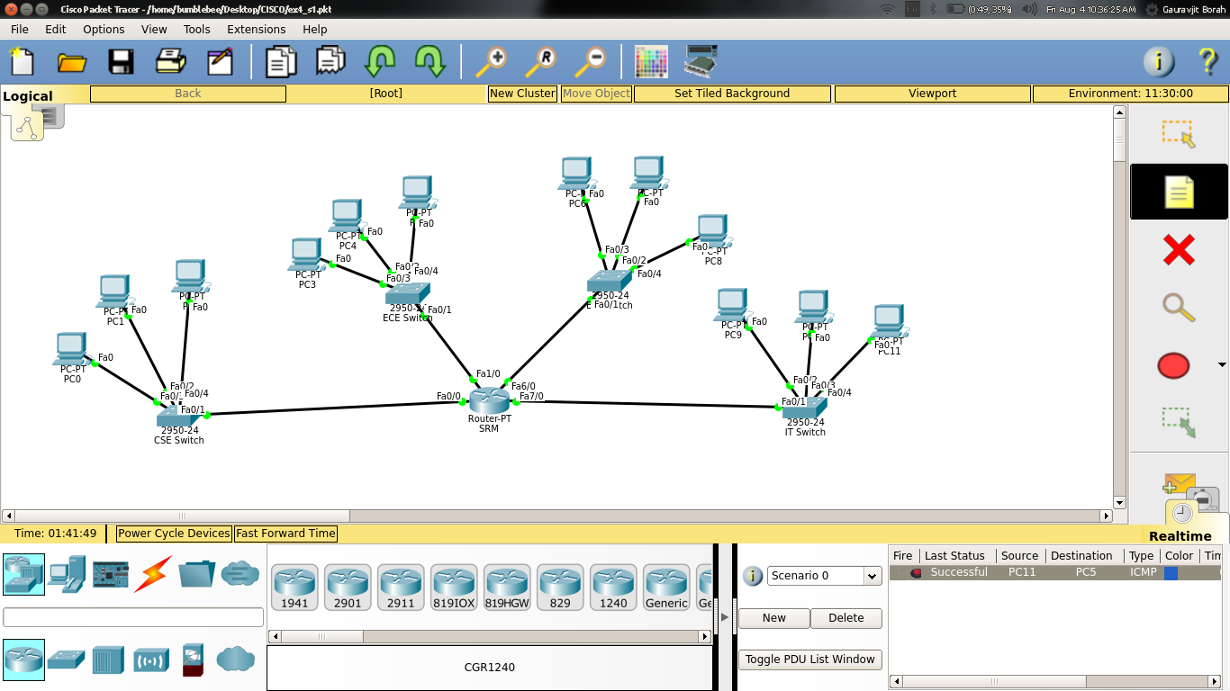

SRM#show ip route

Codes: C - connected, S - static, I - IGRP, R - RIP, M - mobile, B - BGP

D - EIGRP, EX - EIGRP external, O - OSPF, IA - OSPF inter area

N1 - OSPF NSSA external type 1, N2 - OSPF NSSA external type 2

E1 - OSPF external type 1, E2 - OSPF external type 2, E - EGP

i - IS-IS, L1 - IS-IS level-1, L2 - IS-IS level-2, ia - IS-IS inter area

* - candidate default, U - per-user static route, o - ODR

P - periodic downloaded static route

Gateway of last resort is not set

192.168.10.0/24 is variably subnetted, 4 subnets, 2 masks

C 192.168.10.0/25 is directly connected, FastEthernet0/0

C 192.168.10.128/27 is directly connected, FastEthernet1/0

C 192.168.10.160/27 is directly connected, FastEthernet6/0

C 192.168.10.192/27 is directly connected, FastEthernet7/0

SRM#show running-config

Building configuration...

Current configuration : 1145 bytes

!

version 12.2

no service timestamps log datetime msec

no service timestamps debug datetime msec

service password-encryption

!

hostname SRM

!

enable secret 5 $1$mERr$hx5rVt7rPNoS4wqbXKX7m0

!

no ip cef

no ipv6 cef

!

interface FastEthernet0/0

ip address 192.168.10.1 255.255.255.128

duplex auto

speed auto

!

interface FastEthernet1/0

ip address 192.168.10.129 255.255.255.224

duplex auto

speed auto

!

interface Serial2/0

no ip address

clock rate 2000000

shutdown

!

interface Serial3/0

no ip address

clock rate 2000000

shutdown

!

interface FastEthernet4/0

no ip address

shutdown

!

interface FastEthernet5/0

no ip address

shutdown

!

interface FastEthernet6/0

ip address 192.168.10.161 255.255.255.224

duplex auto

speed auto

!

interface FastEthernet7/0

ip address 192.168.10.193 255.255.255.224

duplex auto

speed auto

!

router rip

!

ip classless

!

ip flow-export version 9

!

banner motd ^CSRM Router COnsole^C

!

line con 0

password 7 0822455D0A16

login

!

line aux 0

!

line vty 0 4

password 7 0822455D0A16

login

line vty 5 15

password 7 0822455D0A16

login

!

end

**Scenario 2**

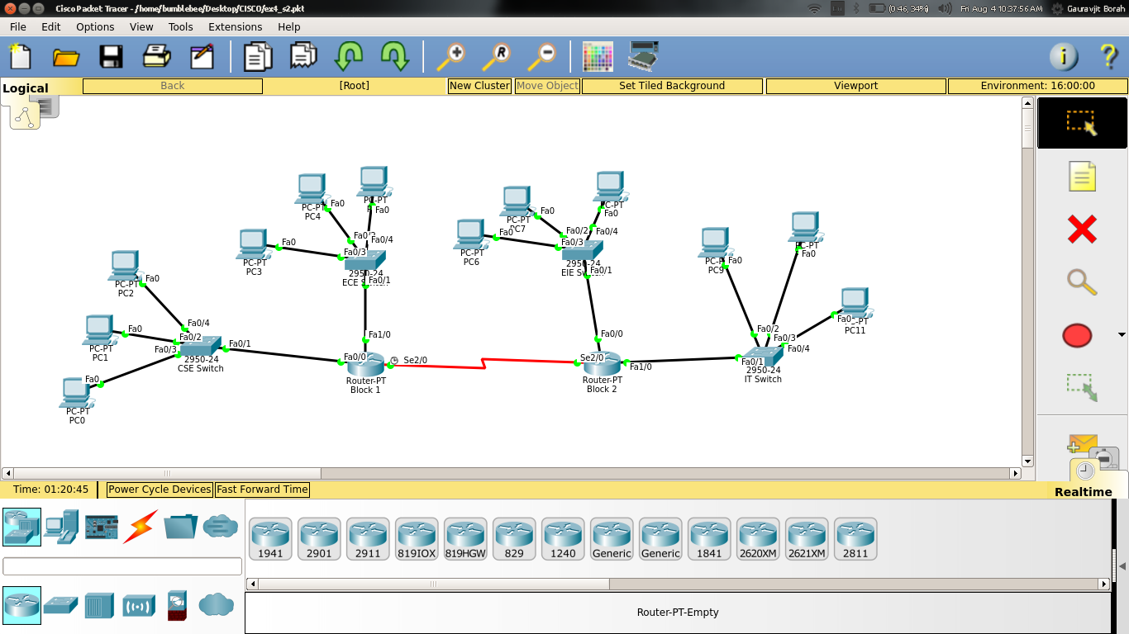

Block 1 Router

Block1#show ip route

Codes: C - connected, S - static, I - IGRP, R - RIP, M - mobile, B - BGP

D - EIGRP, EX - EIGRP external, O - OSPF, IA - OSPF inter area

N1 - OSPF NSSA external type 1, N2 - OSPF NSSA external type 2

E1 - OSPF external type 1, E2 - OSPF external type 2, E - EGP

i - IS-IS, L1 - IS-IS level-1, L2 - IS-IS level-2, ia - IS-IS inter area

* - candidate default, U - per-user static route, o - ODR

P - periodic downloaded static route

Gateway of last resort is 0.0.0.0 to network 0.0.0.0

192.168.10.0/24 is variably subnetted, 3 subnets, 3 masks

C 192.168.10.0/25 is directly connected, FastEthernet0/0

C 192.168.10.128/27 is directly connected, FastEthernet1/0

C 192.168.10.224/30 is directly connected, Serial2/0

S* 0.0.0.0/0 is directly connected, Serial2/0

Block1#show running-config

Building configuration...

Current configuration : 997 bytes

!

version 12.2

no service timestamps log datetime msec

no service timestamps debug datetime msec

service password-encryption

!

hostname Block1

!

enable secret 5 $1$mERr$hx5rVt7rPNoS4wqbXKX7m0

!

ip cef

no ipv6 cef

!

interface FastEthernet0/0

ip address 192.168.10.1 255.255.255.128

duplex auto

speed auto

!

interface FastEthernet1/0

ip address 192.168.10.129 255.255.255.224

duplex auto

speed auto

!

interface Serial2/0

ip address 192.168.10.225 255.255.255.252

clock rate 2000000

!

interface Serial3/0

no ip address

clock rate 2000000

shutdown

!

interface FastEthernet4/0

no ip address

shutdown

!

interface FastEthernet5/0

no ip address

shutdown

!

ip classless

ip route 0.0.0.0 0.0.0.0 Serial2/0

!

ip flow-export version 9

!

banner motd ^CBlock1 Router Console^C

!

line con 0

password 7 0822455D0A16

login

!

line aux 0

!

line vty 0 4

password 7 0822455D0A16

login

line vty 5 15

password 7 0822455D0A16

login

!

end

**Block 2**

Block2#show ip route

Codes: C - connected, S - static, I - IGRP, R - RIP, M - mobile, B - BGP

D - EIGRP, EX - EIGRP external, O - OSPF, IA - OSPF inter area

N1 - OSPF NSSA external type 1, N2 - OSPF NSSA external type 2

E1 - OSPF external type 1, E2 - OSPF external type 2, E - EGP

i - IS-IS, L1 - IS-IS level-1, L2 - IS-IS level-2, ia - IS-IS inter area

* - candidate default, U - per-user static route, o - ODR

P - periodic downloaded static route

Gateway of last resort is 0.0.0.0 to network 0.0.0.0

192.168.10.0/24 is variably subnetted, 3 subnets, 2 masks

C 192.168.10.160/27 is directly connected, FastEthernet0/0

C 192.168.10.192/27 is directly connected, FastEthernet1/0

C 192.168.10.224/30 is directly connected, Serial2/0

S* 0.0.0.0/0 is directly connected, Serial2/0

Block2#show running-config

Building configuration...

Current configuration : 1005 bytes

!

version 12.2

no service timestamps log datetime msec

no service timestamps debug datetime msec

service password-encryption

!

hostname Block2

!

enable secret 5 $1$mERr$hx5rVt7rPNoS4wqbXKX7m0

!

ip cef

no ipv6 cef

!

interface FastEthernet0/0

ip address 192.168.10.161 255.255.255.224

duplex auto

speed auto

!

interface FastEthernet1/0

ip address 192.168.10.193 255.255.255.224

duplex auto

speed auto

!

interface Serial2/0

ip address 192.168.10.226 255.255.255.252

!

interface Serial3/0

no ip address

clock rate 2000000

shutdown

!

interface FastEthernet4/0

no ip address

shutdown

!

interface FastEthernet5/0

no ip address

shutdown

!

router rip

!

ip classless

ip route 0.0.0.0 0.0.0.0 Serial2/0

!

ip flow-export version 9

!

no cdp run

!

banner motd ^CBlock2 Router Console^C

!

line con 0

password 7 0822455D0A16

login

!

line aux 0

!

line vty 0 4

password 7 0822455D0A16

login

line vty 5 15

password 7 0822455D0A16

login

!

end

**Scenario 3**

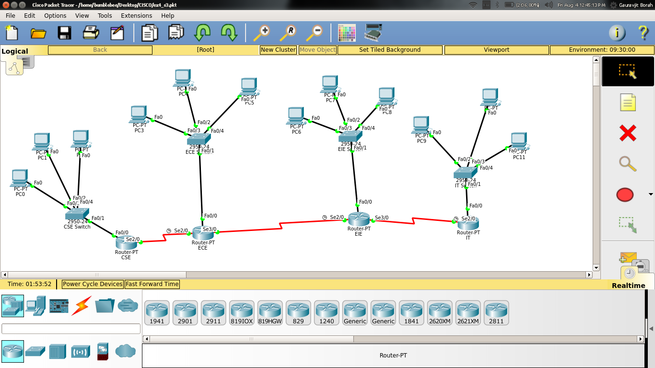

**Router 1 CSE**

CSE#show ip route

Codes: C - connected, S - static, I - IGRP, R - RIP, M - mobile, B - BGP

D - EIGRP, EX - EIGRP external, O - OSPF, IA - OSPF inter area

N1 - OSPF NSSA external type 1, N2 - OSPF NSSA external type 2

E1 - OSPF external type 1, E2 - OSPF external type 2, E - EGP

i - IS-IS, L1 - IS-IS level-1, L2 - IS-IS level-2, ia - IS-IS inter area

* - candidate default, U - per-user static route, o - ODR

P - periodic downloaded static route

Gateway of last resort is 0.0.0.0 to network 0.0.0.0

192.168.10.0/24 is variably subnetted, 2 subnets, 2 masks

C 192.168.10.0/25 is directly connected, FastEthernet0/0

C 192.168.10.224/30 is directly connected, Serial2/0

S* 0.0.0.0/0 is directly connected, Serial2/0

CSE#show running-config

Building configuration...

Current configuration : 953 bytes

!

version 12.2

no service timestamps log datetime msec

no service timestamps debug datetime msec

service password-encryption

!

hostname CSE

!

enable secret 5 $1$mERr$hx5rVt7rPNoS4wqbXKX7m0

!

ip cef

no ipv6 cef

!

interface FastEthernet0/0

ip address 192.168.10.1 255.255.255.128

duplex auto

speed auto

!

interface FastEthernet1/0

no ip address

duplex auto

speed auto

shutdown

!

interface Serial2/0

ip address 192.168.10.225 255.255.255.252

!

interface Serial3/0

no ip address

clock rate 2000000

shutdown

!

interface FastEthernet4/0

no ip address

shutdown

!

interface FastEthernet5/0

no ip address

shutdown

!

ip classless

ip route 0.0.0.0 0.0.0.0 Serial2/0

!

ip flow-export version 9

!

banner motd ^CCSE Router Console^C

!

line con 0

password 7 0822455D0A16

login

!

line aux 0

!

line vty 0 4

password 7 0822455D0A16

login

line vty 5 15

password 7 0822455D0A16

login

!

end

**Router 2 ECE**

ECE#show ip route

Codes: C - connected, S - static, I - IGRP, R - RIP, M - mobile, B - BGP

D - EIGRP, EX - EIGRP external, O - OSPF, IA - OSPF inter area

N1 - OSPF NSSA external type 1, N2 - OSPF NSSA external type 2

E1 - OSPF external type 1, E2 - OSPF external type 2, E - EGP

i - IS-IS, L1 - IS-IS level-1, L2 - IS-IS level-2, ia - IS-IS inter area

* - candidate default, U - per-user static route, o - ODR

P - periodic downloaded static route

Gateway of last resort is not set

192.168.10.0/24 is variably subnetted, 6 subnets, 3 masks

S 192.168.10.0/25 is directly connected, Serial2/0

C 192.168.10.128/27 is directly connected, FastEthernet0/0

S 192.168.10.160/27 is directly connected, Serial3/0

S 192.168.10.192/27 is directly connected, Serial3/0

C 192.168.10.224/30 is directly connected, Serial2/0

C 192.168.10.228/30 is directly connected, Serial3/0

ECE#show running-config

Building configuration...

Current configuration : 1101 bytes

!

version 12.2

no service timestamps log datetime msec

no service timestamps debug datetime msec

service password-encryption

!

hostname ECE

!

enable secret 5 $1$mERr$hx5rVt7rPNoS4wqbXKX7m0

!

ip cef

no ipv6 cef

!

interface FastEthernet0/0

ip address 192.168.10.129 255.255.255.224

duplex auto

speed auto

!

interface FastEthernet1/0

no ip address

duplex auto

speed auto

shutdown

!

interface Serial2/0

ip address 192.168.10.226 255.255.255.252

clock rate 2000000

!

interface Serial3/0

ip address 192.168.10.229 255.255.255.252

!

interface FastEthernet4/0

no ip address

shutdown

!

interface FastEthernet5/0

no ip address

shutdown

!

ip classless

ip route 192.168.10.0 255.255.255.128 Serial2/0

ip route 192.168.10.160 255.255.255.224 Serial3/0

ip route 192.168.10.192 255.255.255.224 Serial3/0

!

ip flow-export version 9

!

no cdp run

!

banner motd ^CECE Router Console^C

!

line con 0

password 7 0822455D0A16

login

!

line aux 0

!

line vty 0 4

password 7 0822455D0A16

login

line vty 5 15

password 7 0822455D0A16

login

!

end

**Router 3 EIE**

EIE#show ip route

Codes: C - connected, S - static, I - IGRP, R - RIP, M - mobile, B - BGP

D - EIGRP, EX - EIGRP external, O - OSPF, IA - OSPF inter area

N1 - OSPF NSSA external type 1, N2 - OSPF NSSA external type 2

E1 - OSPF external type 1, E2 - OSPF external type 2, E - EGP

i - IS-IS, L1 - IS-IS level-1, L2 - IS-IS level-2, ia - IS-IS inter area

* - candidate default, U - per-user static route, o - ODR

P - periodic downloaded static route

Gateway of last resort is not set

192.168.10.0/24 is variably subnetted, 6 subnets, 3 masks

S 192.168.10.0/25 is directly connected, Serial2/0

S 192.168.10.128/27 is directly connected, Serial2/0

C 192.168.10.160/27 is directly connected, FastEthernet0/0

S 192.168.10.192/27 is directly connected, Serial3/0

C 192.168.10.228/30 is directly connected, Serial2/0

C 192.168.10.232/30 is directly connected, Serial3/0

EIE#show running-config

Building configuration...

Current configuration : 1101 bytes

!

version 12.2

no service timestamps log datetime msec

no service timestamps debug datetime msec

service password-encryption

!

hostname EIE

!

enable secret 5 $1$mERr$hx5rVt7rPNoS4wqbXKX7m0

!

ip cef

no ipv6 cef

!

interface FastEthernet0/0

ip address 192.168.10.161 255.255.255.224

duplex auto

speed auto

!

interface FastEthernet1/0

no ip address

duplex auto

speed auto

shutdown

!

interface Serial2/0

ip address 192.168.10.230 255.255.255.252

clock rate 2000000

!

interface Serial3/0

ip address 192.168.10.233 255.255.255.252

!

interface FastEthernet4/0

no ip address

shutdown

!

interface FastEthernet5/0

no ip address

shutdown

!

ip classless

ip route 192.168.10.0 255.255.255.128 Serial2/0

ip route 192.168.10.128 255.255.255.224 Serial2/0

ip route 192.168.10.192 255.255.255.224 Serial3/0

!

ip flow-export version 9

!

no cdp run

!

banner motd ^CEIE Router Console^C

!

line con 0

password 7 0822455D0A16

login

!

line aux 0

!

line vty 0 4

password 7 0822455D0A16

login

line vty 5 15

password 7 0822455D0A16

login

!

end

**Router 4 IT**

IT#show ip route

Codes: C - connected, S - static, I - IGRP, R - RIP, M - mobile, B - BGP

D - EIGRP, EX - EIGRP external, O - OSPF, IA - OSPF inter area

N1 - OSPF NSSA external type 1, N2 - OSPF NSSA external type 2

E1 - OSPF external type 1, E2 - OSPF external type 2, E - EGP

i - IS-IS, L1 - IS-IS level-1, L2 - IS-IS level-2, ia - IS-IS inter area

* - candidate default, U - per-user static route, o - ODR

P - periodic downloaded static route

Gateway of last resort is 0.0.0.0 to network 0.0.0.0

192.168.10.0/24 is variably subnetted, 2 subnets, 2 masks

C 192.168.10.192/27 is directly connected, FastEthernet0/0

C 192.168.10.232/30 is directly connected, Serial2/0

S* 0.0.0.0/0 is directly connected, Serial2/0

IT#show running-config

Building configuration...

Current configuration : 999 bytes

!

version 12.2

no service timestamps log datetime msec

no service timestamps debug datetime msec

service password-encryption

!

hostname IT

!

enable secret 5 $1$mERr$hx5rVt7rPNoS4wqbXKX7m0

!

ip cef

no ipv6 cef

!

interface FastEthernet0/0

ip address 192.168.10.193 255.255.255.224

duplex auto

speed auto

!

interface FastEthernet1/0

no ip address

duplex auto

speed auto

shutdown

!

interface Serial2/0

ip address 192.168.10.234 255.255.255.252

clock rate 2000000

!

interface Serial3/0

no ip address

clock rate 2000000

shutdown

!

interface FastEthernet4/0

no ip address

shutdown

!

interface FastEthernet5/0

no ip address

shutdown

!

router rip

!

ip classless

ip route 0.0.0.0 0.0.0.0 Serial2/0

!

ip flow-export version 9

!

no cdp run

!

banner motd ^CIT Router Console^C

!

line con 0

password 7 0822455D0A16

login

!

line aux 0

!

line vty 0 4

password 7 0822455D0A16

login

line vty 5 15

password 7 0822455D0A16

login

!

End

--------------------------------------------------------------------------------------------------------------------